OBSERVATION1

Dashboard is not matching as per wireframe.

Wireframe:

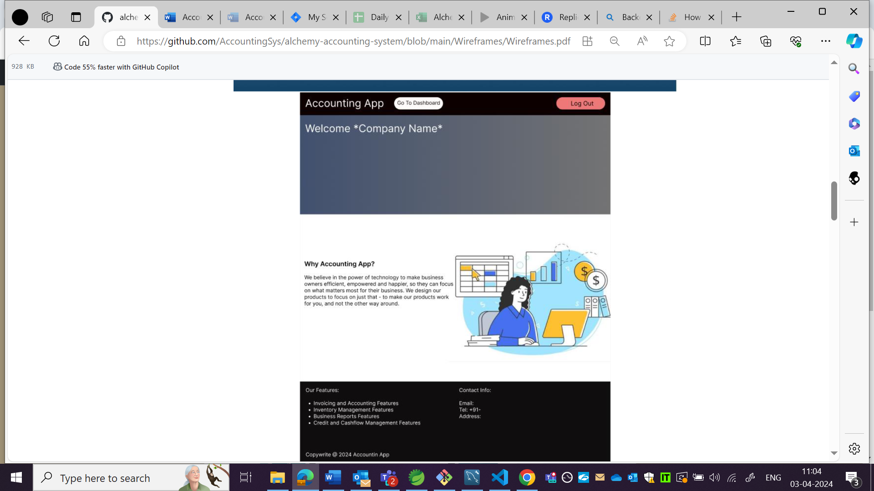

App:

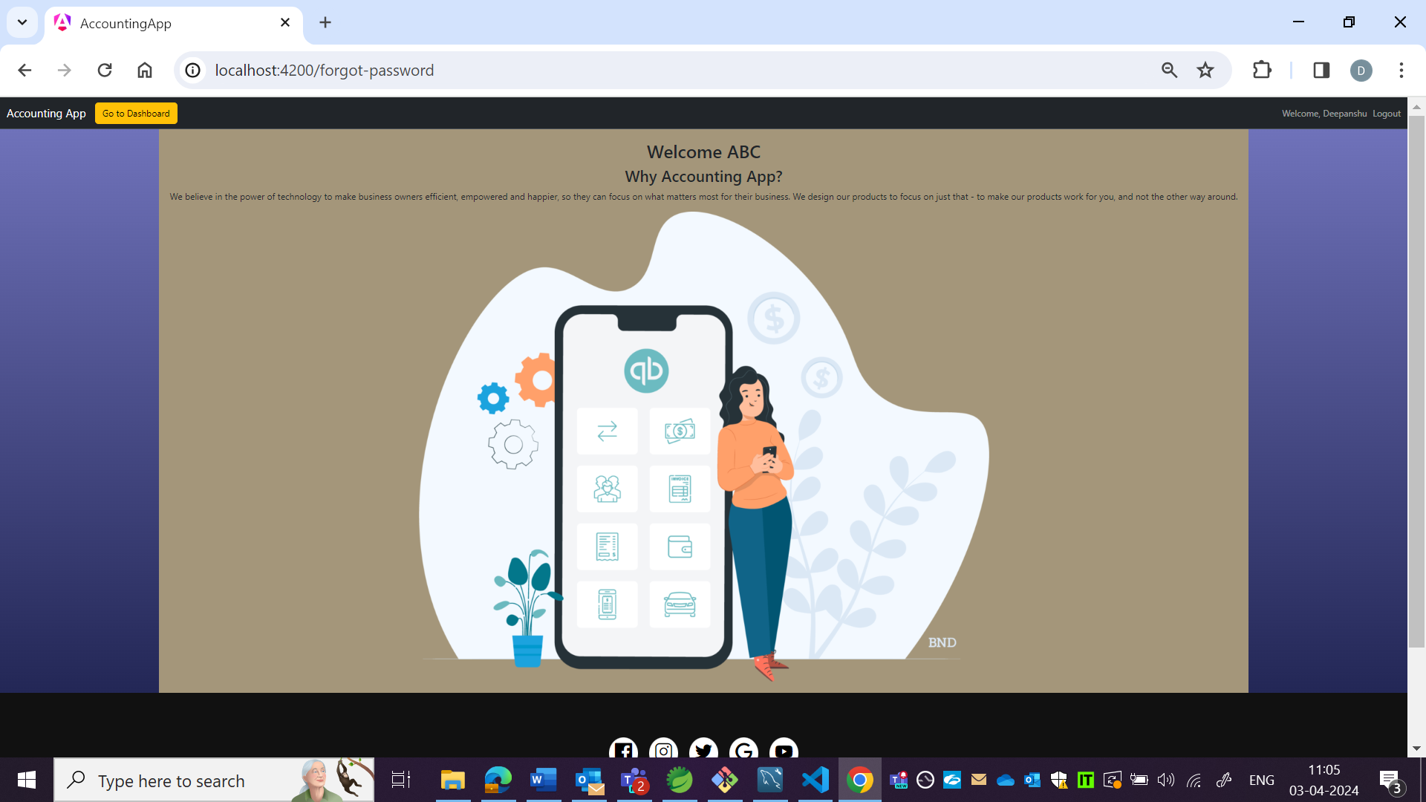

OBSERVATION2:

Footer is not matching as per wireframe.

Wireframe:

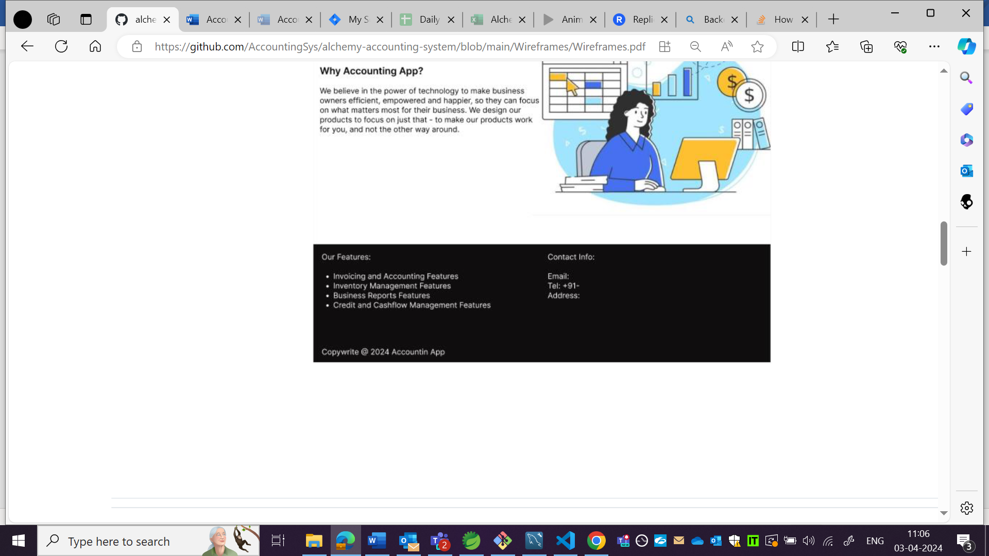

App:

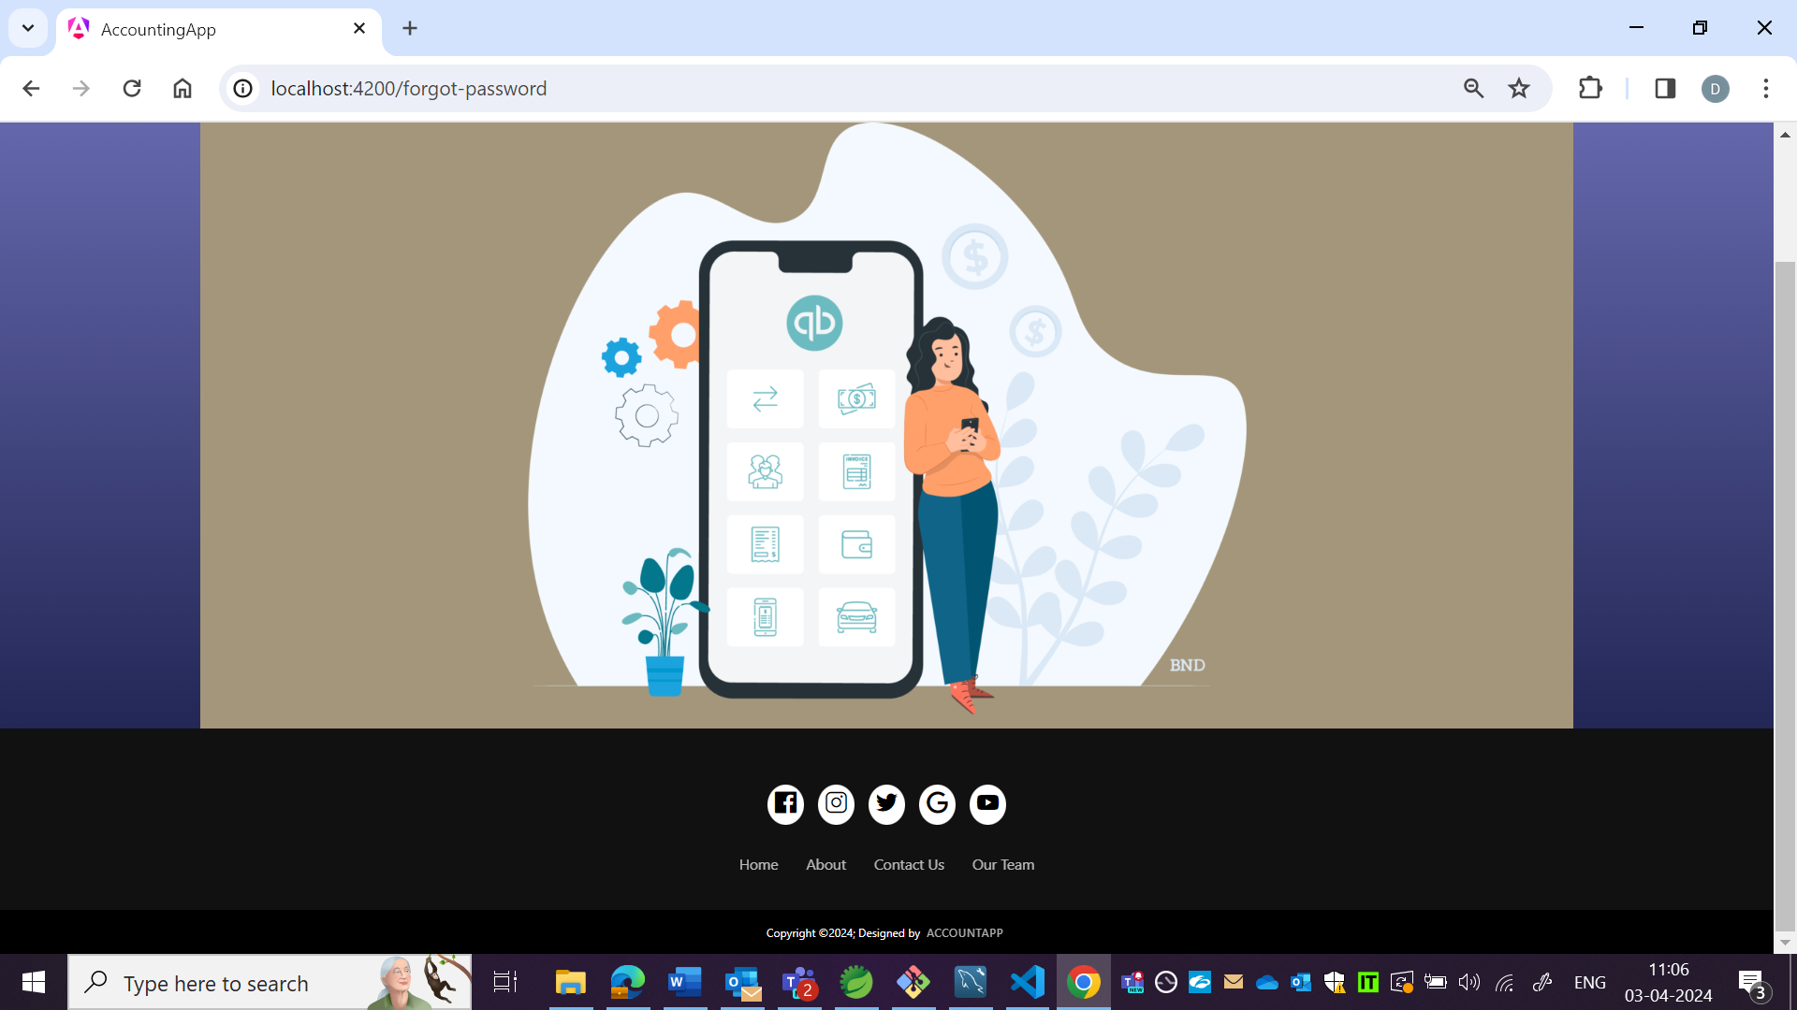

OBSERVATION3:

Top bar detail not matching as per wireframe.

App:

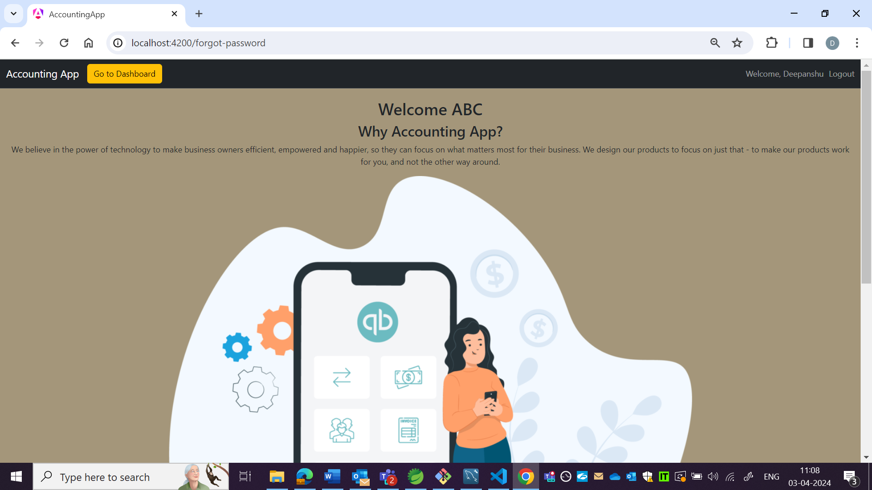

Wireframe:

